EXPERIMENT – 3

EXP NO 3: CREATE A SIMPLE CLOUD SOFTWARE APPLICATION FOR PROPERTY BUYING & RENTAL PROCESS (IN CHENNAI CITY) USING ANY CLOUD SERVICE PROVIDER TO DEMONSTRATE SAAS.
AIM:
To Create a simple cloud software application for Chennai Property Hub
(In Chennai city) using any Cloud Service Provider to demonstrate SaaS.
PROCEDURE:
step1: Go to zoho.com.
step 2: Log into the zoho.com.
step 3: Select one application step.
step4: Enter application name as Chennai Property Hub.
step 5: Created new application Chennai Property Hub.
step 6: Select one form
step 7: The software has been created.
OUTPUT:
FORM 1 –Property Master Form

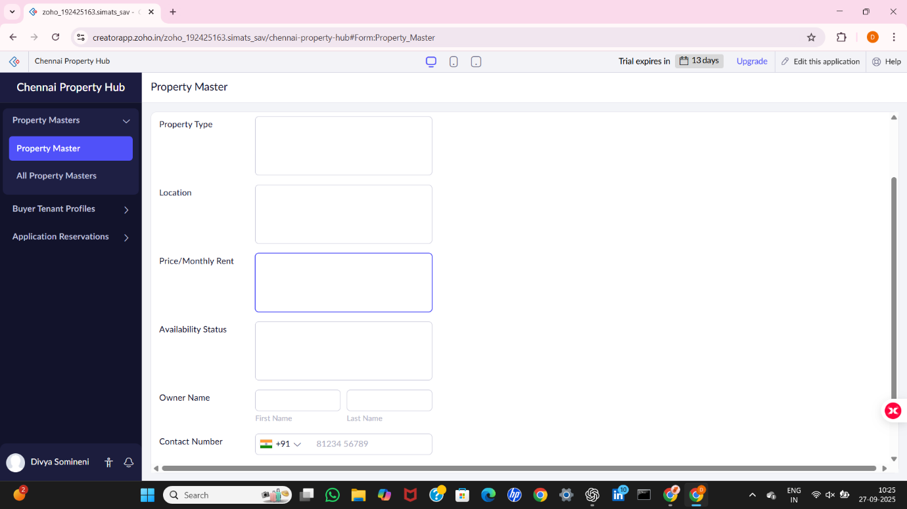
FORM 2 –Buyer Tenant Profile Form

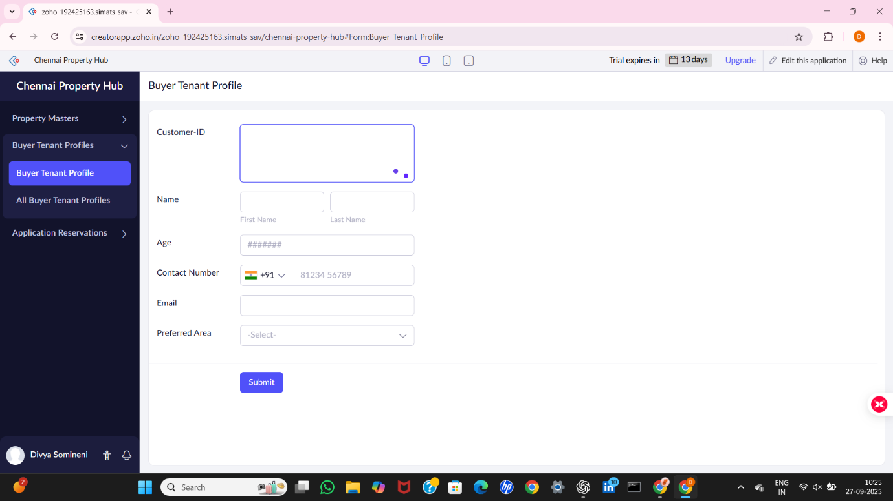

FORM 3 –Application Reservation Form

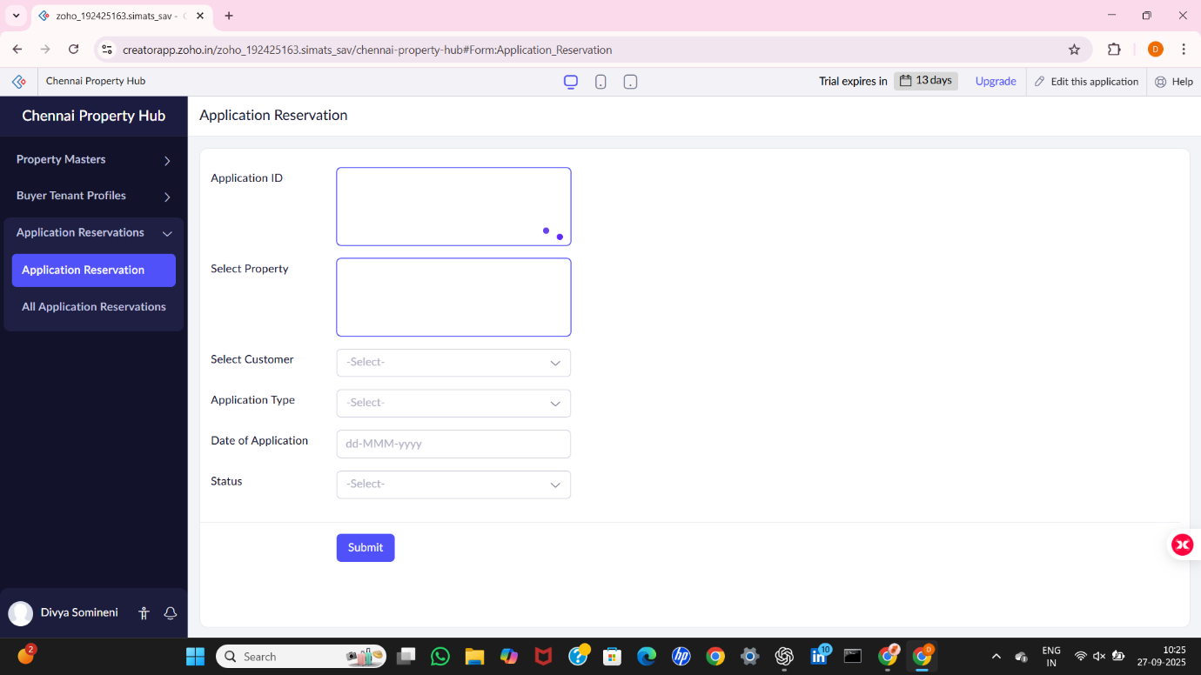

FORM 1 – Property Master Form

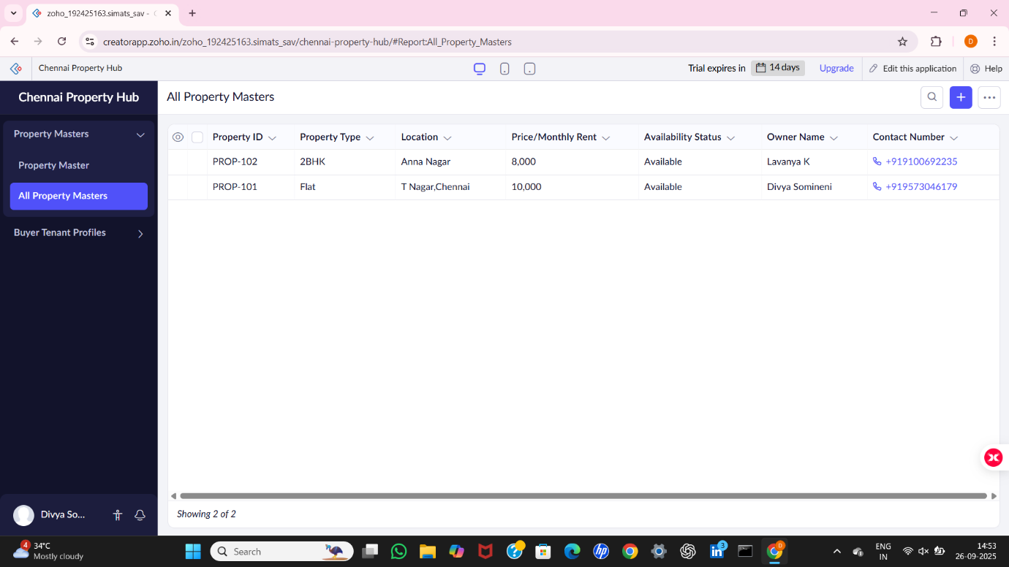

FORM 2 – Buyer Tenant Profile Form

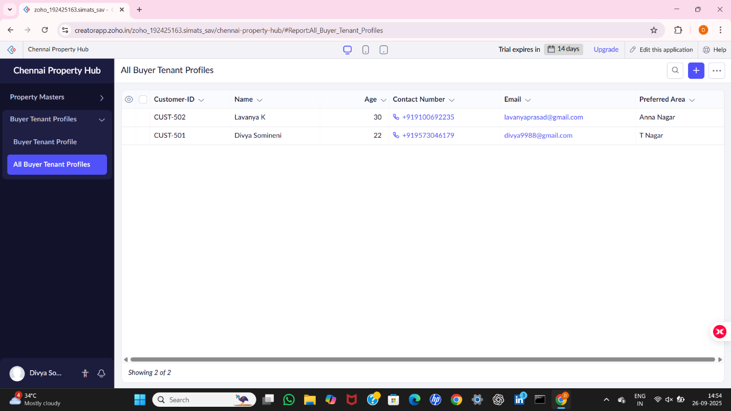

FORM 3 – Application Reservation Form

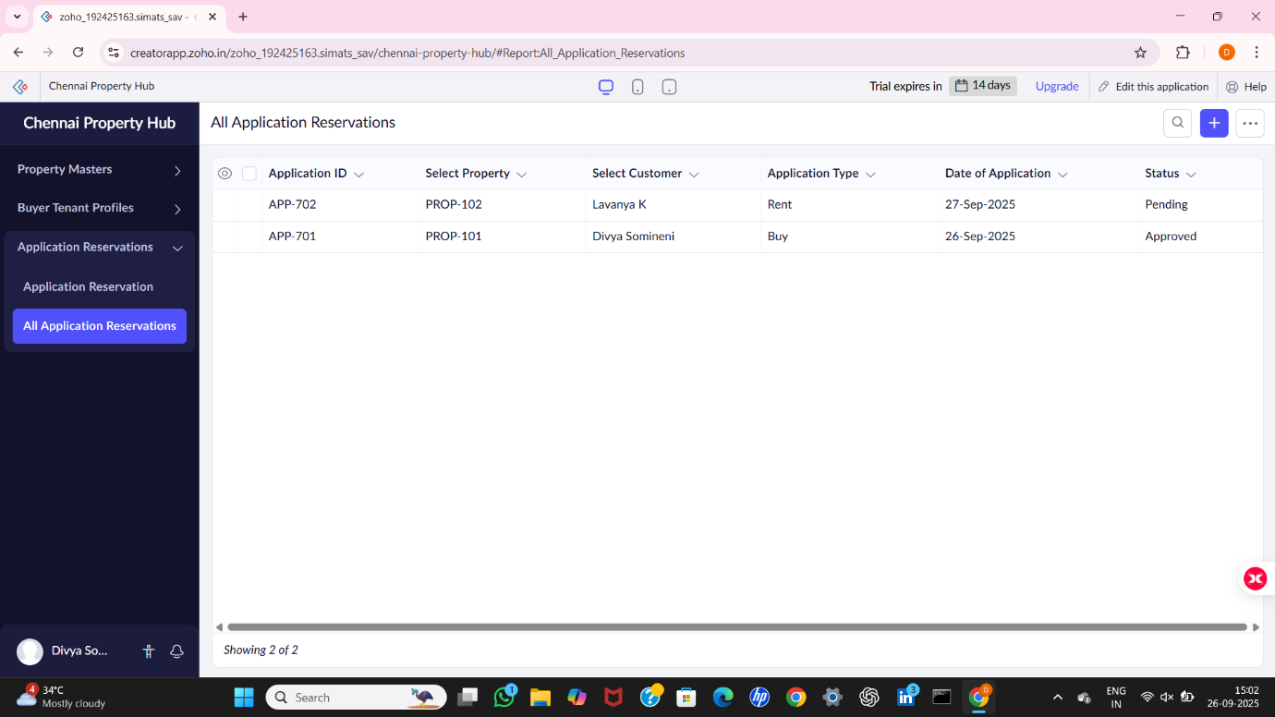

RESULT:
The Chennai Property Hub application was successfully created using Zoho Creator (Cloud SaaS platform) with the following forms:
- Property_Master
- Buyer_Tenant_Profile
- Application_Reservation
This demonstrates SaaS, as customers and owners can access the system online, view properties, submit applications, and track the status entirely via the cloud without installing software.

